Carter Adamson

FISH 558

Lab 2 HW

1/29/2024

**Part A**

1. **Doubling times for r = 0.1 and 0.2? Would it change with different N0? What drives doubling time?**

$$t_{double}=\frac{\ln\left(2\right)}{r}$$

$$t_{double}=\frac{\ln\left(2\right)}{0.1}=6.93 years$$

$$t_{double}=\frac{\ln\left(2\right)}{0.2}=3.47 years$$

The doubling time when r = 0.1 is 6.93 years. When r = 0.2, the population doubles sooner (3.47 years). Since N and N0 are not involved in calculating doubling time, we can say that these doubling times do not depend on the starting size of the population. Thus, it is driven entirely by r, the intrinsic rate of increase, determined from the demographic rates of the population.

1. **Explain the exponential growth model as if to a layman**

Exponential growth models are one way of understanding how a population or group, which could range from fish in a river to money in a bank account, changes over time. We might think of a simple linear growth model, for example, which might say that the population grows by a flat amount of 100 fish every year. If you start with two fish, after five years you will have 502 fish. An exponential growth model is subtly different: instead of growing a flat amount, the population grows a constant proportion. For example, say our population of fish tripes every year. If you start with two fish, after five years you will have 486 fish.

**Part B**

1. **Plot population trajectory for six scenarios, describe how Z affects shape of curve.**

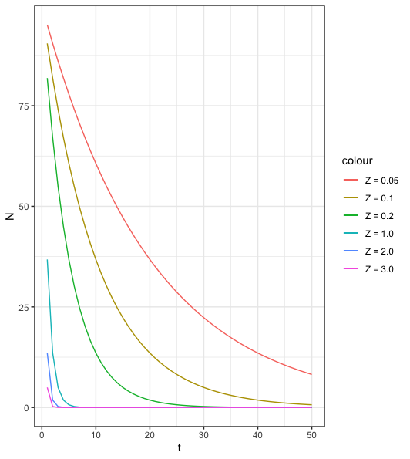

Figure : Plot of population size (N) in number of individuals vs. time (t) in years. Six different scenarios are displayed, according to different values of the instant mortality rate (Z). It is readily apparent that higher values of Z, which correspond with higher mortality rates, result in steeper slopes and a quicker population crash. If Z were negative, this would correspond to “negative mortality”, or births, so the curve would show exponential growth instead of exponential decline.

1. **Derive half-life equation from exponential mortality model.**
$$N_{half}=N_{0}e^{{-Zt}_{half}}$$

$$0.5N_{0}=N_{0}e^{{-Zt}_{half}}$$

$$0.5=e^{{-Zt}_{half}}$$

$$ln⁡(0.5)={-Zt}_{half}$$

$$t_{half}=\frac{\ln\left(0.5\right)}{-Z}$$

2. **Report half-lives for the six scenario and explain the pattern.**

Table : Table of half-lives for the six mortality rates from question 3. Z is the instantaneous mortality rate. Half-lives are measured in years. The mortality rate has a significant impact on half-life (half-life is more than 13 years when Z = 0.05 and less than 0.3 when Z = 3). As mentioned in question 3, the higher values of Z cause quicker population decline, so it follows logically that there would also be shorter half-lives. The faster the decline, the sooner the half-life.

|  |  |
| --- | --- |
| **Z** | **Half-life** |
| 0.05 | 13.86 |
| 0.1 | 6.93 |
| 0.2 | 3.47 |
| 1.0 | 0.69 |
| 2.0 | 0.35 |
| 3.0 | 0.23 |

1. **Following questions:**
   1. **Calculate annual mortality if Z = 0.2 and Z = 1.0**
 $$A=1-e^{-0.2}=0.18$$

 $$A=1-e^{-1.0}=0.63$$

 2. **Describe relationship between annual and instantaneous mortality using the plot.**

The plot provided shows that Z seems to always be greater than or equal to A. Z can have a wider range than A, which is constrained between 0 and 1 (since more than 100% of the population cannot die annually). A and Z appear to be mostly interchangeable for values between 0 and 0.2, after which Z starts to be higher than A (e.g. when Z = 1, A = approximately 0.6).

* 1. **Produce a similar figure.**

Figure : Plot comparing the annual and instantaneous rates of mortality. The solid line represents the relationship between these two rates, while the dashed line is a hypothetical 1:1 line that would be observed if the rates were consistent with each other.

**Part C**

1. **Figure from the exercise**

Figure : Plot of human population (billions of people) vs. year. The blue line represents the actual population trend, while the black line is an exponential model obtained through trial and error. Key parameters of the model are an initial population size of 2.56 billion in 1950, and an intrinsic rate of increase r of 0.017. RSS = 2.35.

1. **Short essay: discussion of the world population doubling time graph.**

The graph shows the doubling time of the world population at throughout time, from before 1600 to 2100. If the population were growing exponentially, doubling time would be constant regardless of population size. As can be seen in the figure, this is clearly not the case, as doubling time both decreases and increases at various points in time. Under logistic growth, doubling time would increase until the population hits half of the carrying capacity, at which point it would no longer be possible to double. However, in this case, even though the population is increasing overall, we see doubling time decrease. This indicates that the population isn’t experiencing exponential *or* logistic growth. This may be due to the fact that people generally have fewer children now than in the past, reflective of shifts in culture and medicine. Additionally, a logistic model may be unsuitable because humans have a tendency to “augment” or otherwise change the carrying capacity to exist in numbers that their unmodified environment couldn’t support.

1. **Hours of work**

3 hours

1. **Group work**

